**Name : Mohammedsarver kittur**

**USN : 01fe20mca043**

**CRUD operations in mongoose**

**Register:**

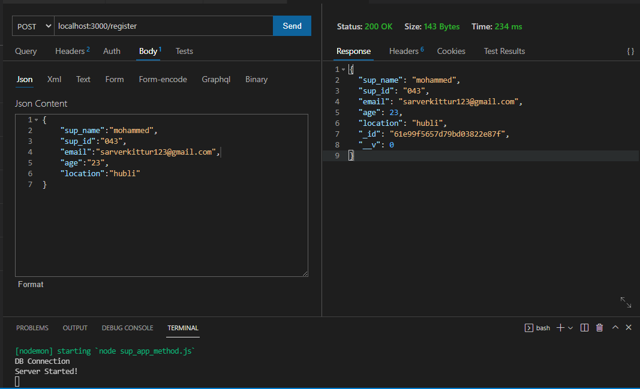

**Update:**

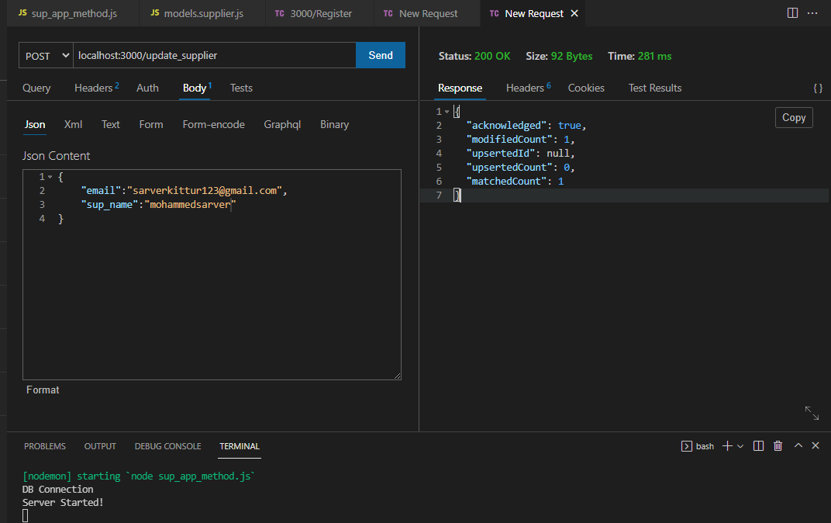

**Delete :**

